**Ultimate Buying Guide and Tips For Car Battery:**

**in 2021**

How do you feel when you're trying to start the automobile in the morning and it won't just happen? In fact, this is an irritating and confusing experience. It doesn't last forever regardless of the quality of your vehicle maintenance and battery. A very vital aspect of your automobile is its battery. You wouldn't be able to start your engine initially without your auto battery. However, we seldom notice something like anything in our current world of technology unless something goes wrong. So, if you read this battery purchase guide, you may want to know a little more deeply what certain signs to see when you hunt for a new battery for your automobile.

You get superior performance, less trouble, and good automobile batteries last longer than mediocre. Obviously, your optimum battery is tailored to your exact battery demands. It doesn't really matter whether you own a reliable Toyota, an SUV, a sports car, or a BMW, and your new performance battery for your vehicle suddenly fails. This article is, however, the best location to start learning to be satisfied with, so that you have an educated option.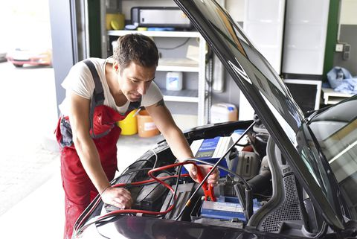

**Which Brand to Choose?**

Most people who have already visited an automobile shop, undoubtedly have recommendations for your automobile maker on which battery brand to pursue. In addition, the battery that fits your automobile relies on the dimensions of the battery, typically exclusive to certain brands. Instead of spending a few pennies on a cheap brand, you should purchase the batteries from well-recognized, established brands. An excellent brand battery is far more likely to give you a lot of performance and life. And if something goes wrong, you're calm since you have a guarantee to cover your purchase against production faults. Purchase your finest brand.

**Types of Car Battery**

Car batteries differ in several ways to operate with the requirements of different vehicles and are typically model-specific year by year. There is a commonality in how many automotive batteries function. AGM, EFB, Lead Acid: 3 different types of batteries have many shared characteristics. The great performance of AGM and EFB batteries is characterized. There are two primary varieties when it comes to current automobile batteries: the classic acid battery and the glass tube or the AGM style battery. 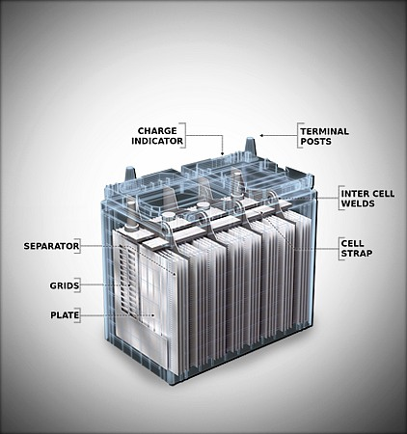

Traditional batteries of lead-acid are inexpensive and dead easy to use. They're around for years and new sealed batteries don't even require you to "top" the battery off with water or "gas" or discharge inflammable hydrogen. AGM batteries have a lot to do with them, though. Their internal construction allows them to be much more robust than traditional lead-acid batteries. AGM batteries not only deliver higher performance, but they also keep their charge longer than ordinary batteries. Deeper drain cycles are also maintained. AGM batteries can cost nearly double, however.

**Be Sure About Battery Size**

The size of the battery frequently depends on its capacity. That is why which battery is acceptable for you often depends on the size standards for your car. Furthermore, your engine compartment is built to house a battery of one size and may not fit other sizes adequately. Battery sizes include combinations of numbers and letters such as 65, 75, 24/24F, 34/78, 51R, commonly displayed on the battery label. 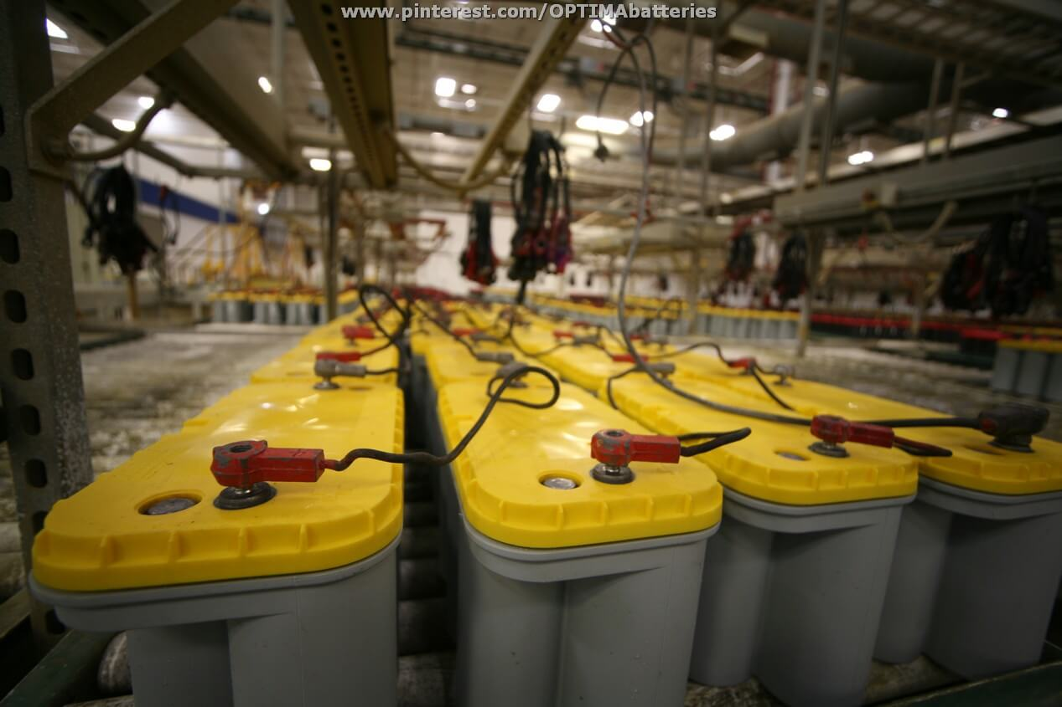

In addition, different sizes are exclusive to certain vehicle markings and types. So read in the handbook of your owner and get the right battery for your automobile. Eventually, your alternator will be damaged by the improper automobile battery size. Small cells will finally make the alternator function to provide the energy flow. But larger battery power from your alternator is also required. These larger batteries must be loaded with the alternator.

**Long Reserve Capacity**

With all other essentials, battery backup is also a very noticeable point while buying a car battery. The amount of time that your battery can provide to run your car if your charging system goes down for any issue, is known as the reserve capacity of your battery. It is fairly usual to leave your car in the ignition in the garage or leave your lights on overnight. The capability of the reserve is measured by standard tests and is generally written on a battery label. You should always spring for a battery that has a reserve capacity of at least 90 RC, that is to say, 90 minutes of reserve capacity. This should lead you through to any problems you could experience on the road with an alternator.

**Beware of Cold Cranking Amps**

Any kind of machine needs heat to survive for a long run. Once the environment gets cold, performance gets down gradually. Cold weather not only decreases battery performance but also it takes a lot of work to start up your motor. In this case, CCA or cold cranking amps is a good measure of battery performance in a cold climate. This is the amount of power or ampere that the battery can supply at 0 degrees Fahrenheit for at least 30 seconds and does not exceed the minimum voltage. Usually, the manufacturers prominently announce this number, although no overboard is needed.

**Battery Life**

The hallmark of the lifespan of your battery is battery life. While most manufacturers will warranty their batteries for 36 months or 3 years, a good battery may live much longer than that. You may use a trickle charger for a good while when your battery is not used for a longer period if you carefully take care of your battery by not allowing deep discharges and not utilizing it. Unfortunately, the battery life can not be assessed by a standard meter and the battery usually takes time on user evaluations and word of mouth.

Battery life can be extended by following some steps. Overcharging and undercharging issues should be solved. The sulfuric acid and distilled water combination are boiled by an overloaded battery. The battery housing might start to melt or swell heat to the touch. Into the sealed battery cells, flammable hydrogen can build up, causing the box to inflate and filter through tiny ventilations. The battery will progressively produce sulphurization if it does not receive enough charge to return the battery to full charge. This error can be caused if the automobile is utilized for short trips or stop-start urban driving just from time to time.

**Check Warranty**

When you buy a car battery, a 36-month warranty is a minimum. If your car battery stops operating under the warranty, it should include free replacement of your battery. Specified manufacturers go further and give a discount on a pro-rata replacement battery purchase if your battery dies in a certain time period after your warranty expires.

**Some Additional Tips**

# Check the battery for physical measurements to fit your engine compartment.

# Don't overspend; the battery is good enough - Spring is the costliest brand you could purchase.

# Get your battery with a trickle charger so that you can take care of it if it is not used or accidentally entirely drained.

# A battery handle is an enormous relief.

# You might consider purchasing a high-performance battery particularly intended for the high.

# Current draw and repetitive charging cycles in your car when you have a lot of accessories or lighting.

# Do not buy a battery resting over six months on the shelf in the showroom; the production date may be found on the label.